**Access Modifiers in Java**

in Java, Access modifiers help to restrict the scope of a class, constructor, variable, method, or data member. It provides security, accessibility, etc to the user depending upon the access modifier used with the element. Let us learn about Java Access Modifiers, their types, and the uses of access modifiers in this article.

## Types of Access Modifiers in Java

There are four types of access modifiers available in Java:

1. Default – No keyword required
2. Private
3. Protected
4. Public

## Types of Access Modifier

Before you learn about types of access modifiers, make sure you know about [Java Packages](https://www.programiz.com/java-programming/packages-import).

There are four access modifiers keywords in Java and they are:

|  |  |
| --- | --- |
| **Modifier** | **Description** |
| Default | declarations are visible only within the package (package private) |
| Private | declarations are visible within the class only |
| Protected | declarations are visible within the package or all subclasses |
| Public | declarations are visible everywhere |

### **1)Private**

The private access modifier is accessible only within the class.

**Simple example of private access modifier**

In this example, we have created two classes A and Simple. A class contains private data member and private method. We are accessing these private members from outside the class, so there is a compile-time error.

1. **class** A{
2. **private** **int** data=40;
3. **private** **void** msg(){System.out.println("Hello java");}
4. }
6. **public** **class** Simple{
7. **public** **static** **void** main(String args[]){
8. A obj=**new** A();
9. System.out.println(obj.data);//Compile Time Error
10. obj.msg();//Compile Time Error
11. }
12. }

### **2) Default**

If you don't use any modifier, it is treated as **default** by default. The default modifier is accessible only within package. It cannot be accessed from outside the package. It provides more accessibility than private. But, it is more restrictive than protected, and public.

**Example of default access modifier**

In this example, we have created two packages pack and mypack. We are accessing the A class from outside its package, since A class is not public, so it cannot be accessed from outside the package.

1. //save by A.java
2. **package** pack;
3. **class** A{
4. **void** msg(){System.out.println("Hello");}
5. }
6. //save by B.java
7. **package** mypack;
8. **import** pack.*;
9. **class** B{
10. **public** **static** **void** main(String args[]){
11. A obj = **new** A();//Compile Time Error
12. obj.msg();//Compile Time Error
13. }
14. }

In the above example, the scope of class A and its method msg() is default so it cannot be accessed from outside the package.

### **3) Protected**

The **protected access modifier** is accessible within package and outside the package but through inheritance only.

The protected access modifier can be applied on the data member, method and constructor. It can't be applied on the class.

It provides more accessibility than the default modifer.

**Example of protected access modifier**

In this example, we have created the two packages pack and mypack. The A class of pack package is public, so can be accessed from outside the package. But msg method of this package is declared as protected, so it can be accessed from outside the class only through inheritance.

1. //save by A.java
2. **package** pack;
3. **public** **class** A{
4. **protected** **void** msg(){System.out.println("Hello");}
5. }
6. //save by B.java
7. **package** mypack;
8. **import** pack.*;
10. **class** B **extends** A{
11. **public** **static** **void** main(String args[]){
12. B obj = **new** B();
13. obj.msg();
14. }
15. }

Output:Hello

### **4) Public**

The **public access modifier** is accessible everywhere. It has the widest scope among all other modifiers.

**Example of public access modifier**

1. //save by A.java
3. **package** pack;
4. **public** **class** A{
5. **public** **void** msg(){System.out.println("Hello");}
6. }
7. //save by B.java
9. **package** mypack;
10. **import** pack.*;
12. **class** B{
13. **public** **static** **void** main(String args[]){
14. A obj = **new** A();
15. obj.msg();
16. }
17. }

Output:Hello

# Java Package

A **java package** is a group of similar types of classes, interfaces and sub-packages.

Package in java can be categorized in two form, built-in package and user-defined package.

There are many built-in packages such as java, lang, awt, javax, swing, net, io, util, sql etc.

Here, we will have the detailed learning of creating and using user-defined packages.

## **Advantage of Java Package**

1) Java package is used to categorize the classes and interfaces so that they can be easily maintained.

2) Java package provides access protection.

3) Java package removes naming collision.

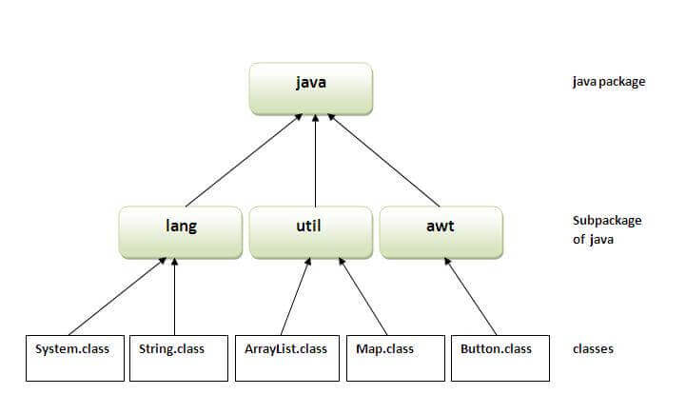

## **How to access package from another package?**

There are three ways to access the package from outside the package.

1. import package.*;
2. import package.classname;
3. fully qualified name.

#### **1) Using packagename.\***

If you use package.* then all the classes and interfaces of this package will be accessible but not subpackages.

The import keyword is used to make the classes and interface of another package accessible to the current package.

## **Example of package that import the packagename.\***

1. //save by A.java
2. **package** pack;
3. **public** **class** A{
4. **public** **void** msg(){System.out.println("Hello");}
5. }
6. //save by B.java
7. **package** mypack;
8. **import** pack.*;
10. **class** B{
11. **public** **static** **void** main(String args[]){
12. A obj = **new** A();
13. obj.msg();
14. }
15. }

Output:Hello

#### **2) Using packagename.classname**

If you import package.classname then only declared class of this package will be accessible.

## **Example of package by import package.classname**

1. //save by A.java
3. **package** pack;
4. **public** **class** A{
5. **public** **void** msg(){System.out.println("Hello");}
6. }
7. //save by B.java
8. **package** mypack;
9. **import** pack.A;
11. **class** B{
12. **public** **static** **void** main(String args[]){
13. A obj = **new** A();
14. obj.msg();
15. }
16. }

Output:Hello

#### **3) Using fully qualified name**

If you use fully qualified name then only declared class of this package will be accessible. Now there is no need to import. But you need to use fully qualified name every time when you are accessing the class or interface.

It is generally used when two packages have same class name e.g. java.util and java.sql packages contain Date class.

## **Example of package by import fully qualified name**

1. //save by A.java
2. **package** pack;
3. **public** **class** A{
4. **public** **void** msg(){System.out.println("Hello");}
5. }
6. //save by B.java
7. **package** mypack;
8. **class** B{
9. **public** **static** **void** main(String args[]){
10. pack.A obj = **new** pack.A();//using fully qualified name
11. obj.msg();
12. }
13. }

Output:Hello